RESOLUTION NO. 25-XXX

A RESOLUTION OF THE CUPERTINO CITY COUNCIL
RATIFYING CERTAIN CLAIMS AND DEMANDS PAYABLE IN THE AMOUNTS AND FROM THE FUNDS AS HEREINAFTER DESCRIBED FOR GENERAL AND MISCELLANEOUS EXPENDITURES FOR THE PERIOD ENDING DECEMBER 26, 2024

WHEREAS, the Director of Administrative Services or their designated representative has certified to accuracy of the following claims and demands and to the availability of funds for payment hereof; and

WHEREAS, the said claims and demands have been audited as required by law.
NOW, THEREFORE, BE IT RESOLVED that the City Council does hereby ratify the following claims and demands in the amounts and from the funds as hereinafter set forth in the attached Payment Register.

PASSED AND ADOPTED at a special meeting of the City Council of the City of Cupertino this 22nd day of January, 2025 by the following vote:

Vote Members of the City Council

AYES:
NOES:
ABSENT:
ABSTAIN:

SIGNED:  ________  Liang Chao, Mayor  City of Cupertino | ________________________  Date
ATTEST:  ________  Kirsten Squarcia, City Clerk | ________________________  Date

CERTIFICATION

The Finance Manager hereby certifies to the accuracy of said records and to the availability of funds for payment.

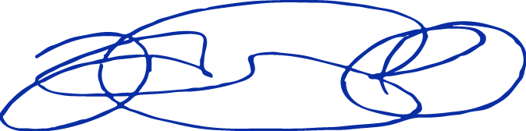

CERTIFIED:
Jonathan Orozco, Finance Manager

